**JEREMY PETERSON DUTOYA**

**PR. EMRE YETGIN – DIRECTOR, CENTER FOR BUSINESS ANALYTICS**

**PMBA-8355-OLB VISUAL ANALYTICS**

HOMEWORK 8 – CREATING BASICS VISUALIZATION TO ANSWER BUSINESS QUESTIONS

Visualization #1 & #2

*Question: Compare the two Product by Sales charts. What are the advantages and disadvantages of using them and the conditions for optimal use?*

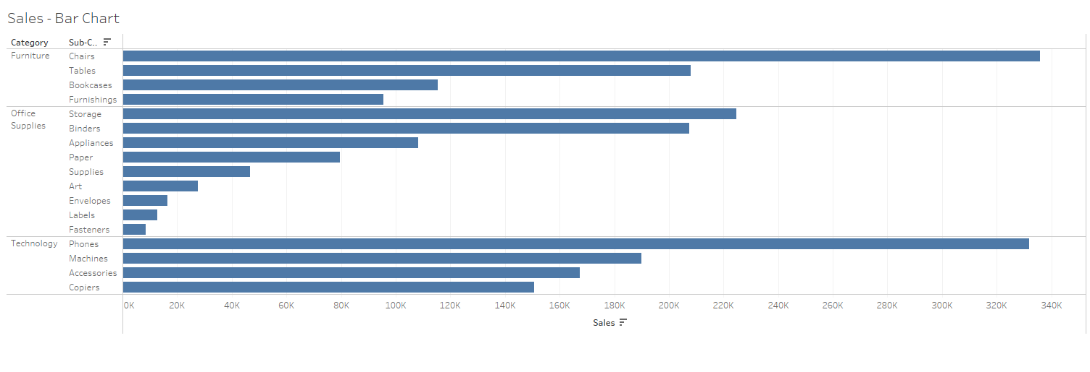

BAR CHART VS. PACK BUBBLE

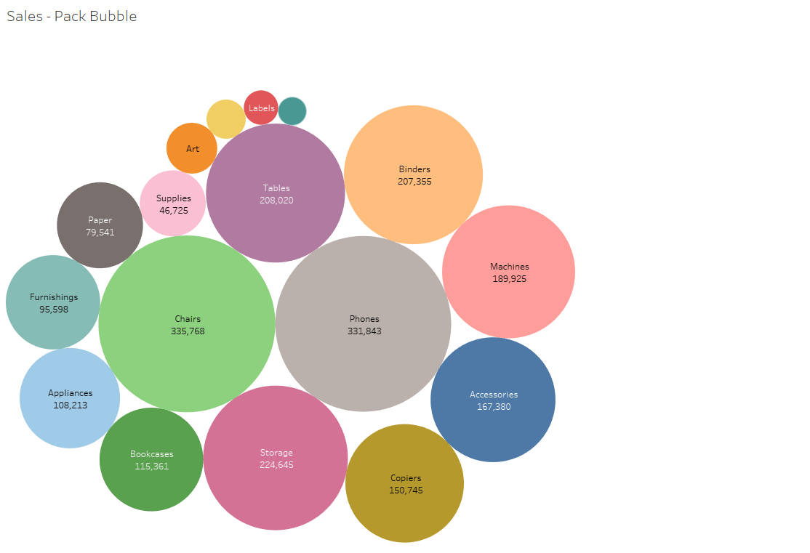

I think the bar chart is the most efficient way to compare numerical data that splits nicely into different categories and to see the different trends quickly as they reveal highs and lows at a glance with the length of each bars. Bar charts are pretty easy to interpret, and there's a very clear relationship between size and value that allows easy comparison even more when they are sorted.

On the other hand, bubble charts are somewhat okay to do comparaison but it is not as easy to interpret the data and draw conclusions using them as it is with the bar chart. The categories and subcategories are not easy to distinguish and even the size of the bubble is not that easy to interpret to do a ranking for example. For this type of chart, I believe it is primordial to sort the result in descending order to really be able to analyze the data while it is only preffered and optional with the bar chart. I remember reading that in general, Bubbles are not their own type of visualization but instead should be viewed as a technique to accentuate data on scatter plots or maps for example.

Vizualization #3

*Question: What region/category has a Negative profit number?*

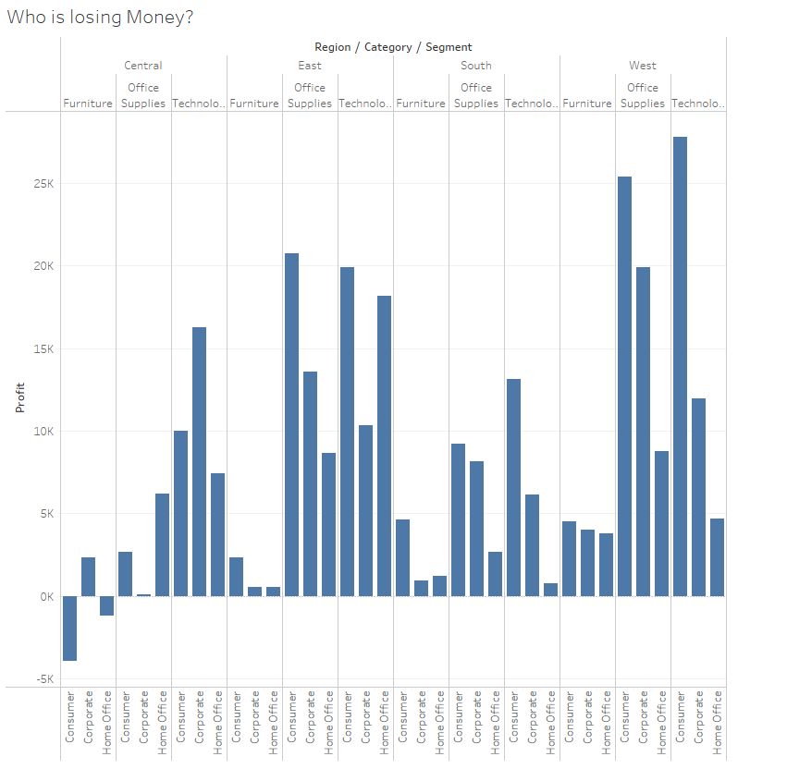

This visualization is very handy because, with a 2 x-axis, the categories of products and regions that have a negative profit are directly apparent and obvious as the bar is under the 0K Profit line. So we can see very quickly that the Furniture of the Central region is the only one having a negative profit. We can even add more precision to this analysis by saying that the Consumer segment ($-3,926) and Home Office segment ($-1,199) are precisely the two Furniture segments of the central region with a negative profit.

Vizualisation #5

*Question: Compare the profits and sales trends in the West region. (Chart below). What observations can you draw from this chart? Could we have used another chart type? Why or Why not?*

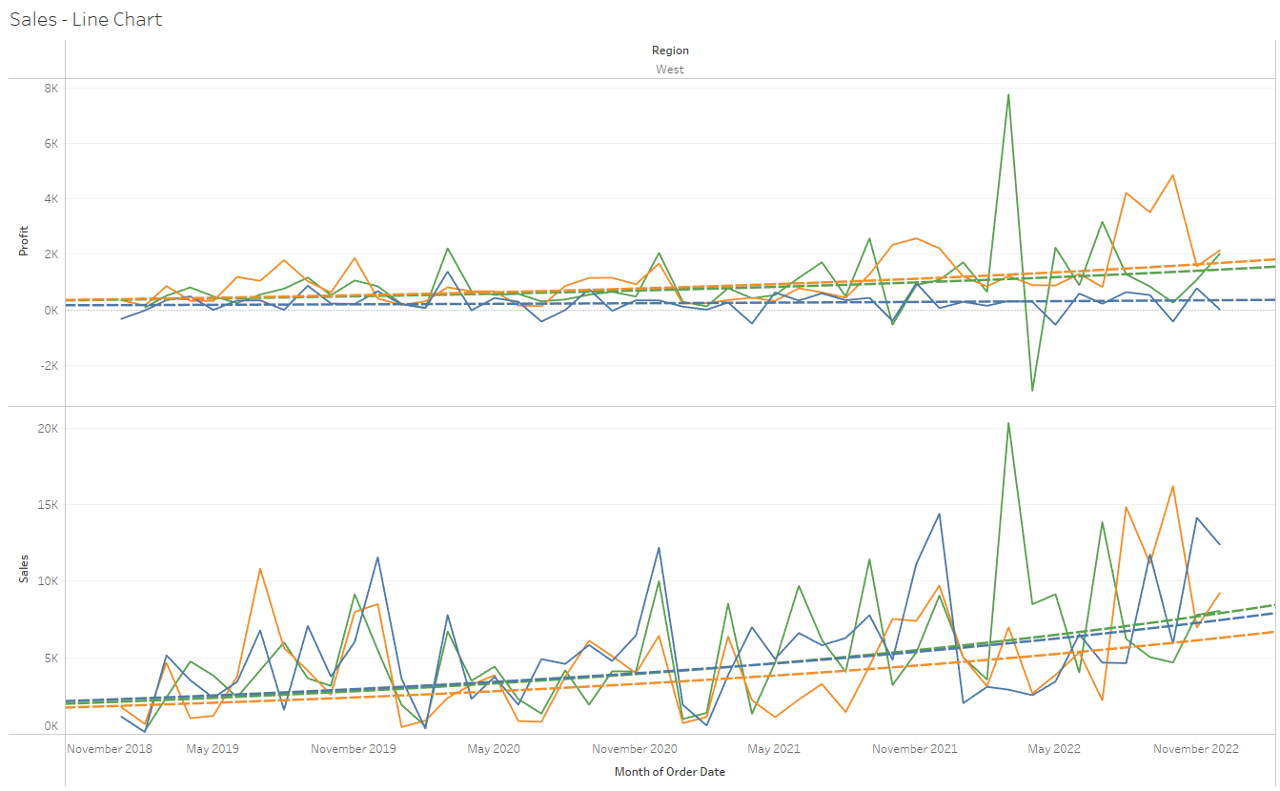

The profits and sales trends in the West region have fluctuated irregularly, in a sawtooth manner, years over years, but thanks to the trend line added to the visualization, we can see that the general trend is a positive increase in sales and profits. It is also possible for us to see that sales and profit vary in a synchronized way, when one increases the other also increases, we notice the peaks and troughs at the same points in time. This implies that sales influence profits but that another factor must also influence profit (discounts) because we can say that the slope of sales is more important than that of profit.

Also we can see something surprising: the trend line of sales of office supplies is the lowest of the three categories but its trend line which represents profit is the highest of the three categories.

I think this reprsentation is the most interesting and relevant for comparing performances and trends over time as it is a continuous variable. However we could also have used a stacked bar chart or a side-by-side bars chart to have a representation that is close to the one obtained with this chart.

Vizualisation #6 & #7

*Question: Which is a better visual representation and why?*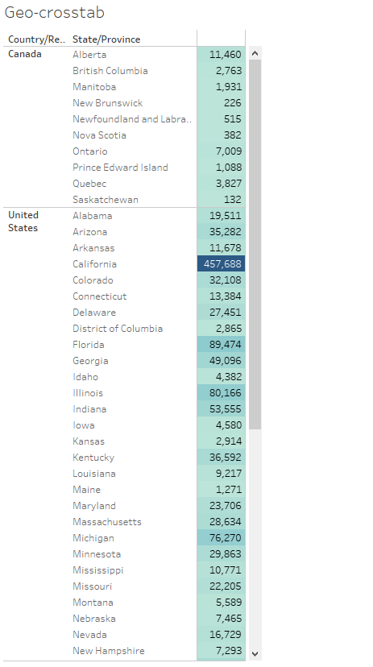

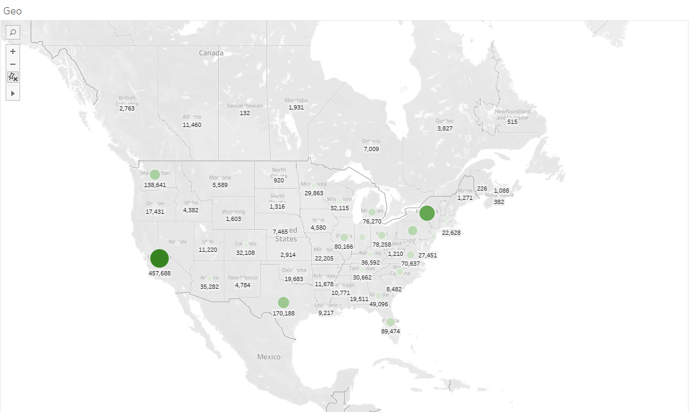

I think the best visualization is the Map because, coupled with the bubbles, it has a better spatial representation of the distribution of sales in the territory according to the states. Indeed, I believe the map visualization is much more visually appealing, it commits the user to interact with the information described on the graph with minimal effort to retain the key information. The marks we added help a lot as they give the key information with the label, the colors and the size of the bubbles that represent the sales volume. It is true that this information is also represented in the crosstab, however, you have to go on and search for it: you have to scroll down and do it several times to compare the values and perform a ranking, while with the map, the size of the spheres give this information really quickly: we can immediately see that California, New York and Texas recorded the best sales. In addition, the fact of adding labels offer more precisions if we really want to deepen our analysis.

In general, I think that when we are dealling with any kind of location data, like the states for our example, we really should use a map chart to visualize the data.

Vizualisation #9

*Question: With this page filter, how was the state of New York doing over time?*

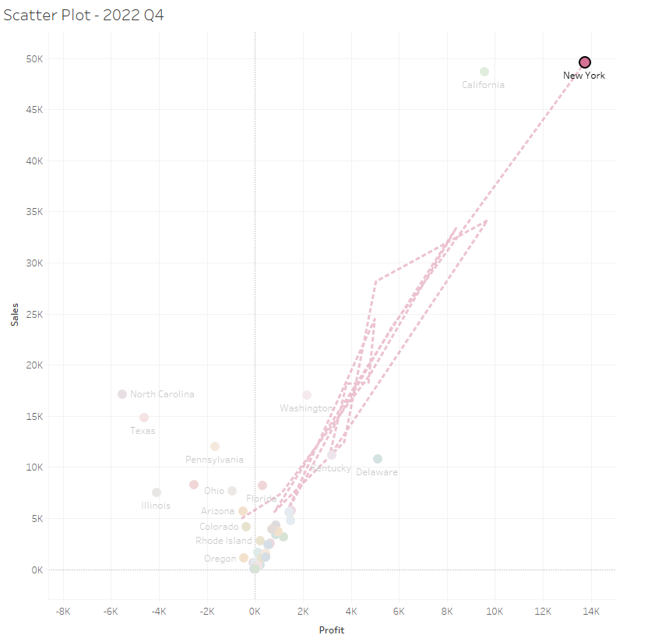

Over time the state of New York recorded sales and profit in constant positive developments. In Q1 of 2019, sales were positive but at their lowest ($5,005) with a negative profit ($-531). This is the only Quarter where the state of New York has recorded a negative profit since 2019. Since then, sales and profit have been steadily increasing. Obviously at the beginning of each year, so at each Q1, the sales volume decreased but during the year the sales and profit increased drastically. For example, at Q4 of 2019, sales were $33,356 for a profit of $8,385. This constant evolution is notably illustrated with a 2022 Q4 recording record figures with sales of $49,621 and a profit of 13,770 making the state of New York the most profitable for the company over the last 3 years.